SIMATS ENGINEERING (SAVEETHA SCHOOL OF ENGINEERING)
Department of Computer Science and Engineering
CO3 ASSESSMENT TOOL 2 – Code Review & Repository Evaluation

Course Code: | CSA10 / CSA1063 | Course Title: | Software Engineering
CO Assessed: | CO3 | Assessment: | Assessment Tool 1 – Code Review & Repository Evaluation
Weightage: | 20% | Total Marks: | 25
CO3 Statement: | Build full-stack applications with an emphasis on containerization, version control, and collaborative development
Student Name: | U. Somesh Kumar | Reg. No.: | 192425019
Date: | 8/8/2026 | Duration: | 60 minutes

Code of Conduct
I U. Somesh Kumar (192425019) (Name / Reg No) certify that this submission is my original work and that I have adhered to the guidelines specified for this assessment. I understand that any violation of academic integrity rules will result in disciplinary action.
Signature of the Student: U. Somesh Kumar
Annexure A – Code Review & Repository Evaluation
Instructions to Students:
Each student has been assigned an individual problem statement. Based on the assigned problem statement, perform a Code Review and Repository Evaluation of your project. Analyze the quality of the source code, repository organization, documentation, coding practices, and overall maintainability. Provide appropriate screenshots, code snippets, diagrams, and justifications wherever applicable.

Assignment Questions
- Problem Overview
  - Explain the assigned problem statement and summarize the implemented solution.
  - Describe the project objectives and key functionalities.
- Repository Organization
  - Evaluate the repository structure, folder organization, and file naming conventions.
  - Justify how the repository layout supports maintainability and collaboration.
- Code Quality Review
  - Review the source code for readability, modularity, coding standards, and documentation.
  - Identify strengths and areas for improvement.
- Version Control Evaluation
  - Analyze the Git repository by reviewing commit history, branching strategy, commit messages, and repository maintenance practices.
  - Explain how version control supports collaborative software development.
- Code Testing and Validation
  - Demonstrate that the application functions correctly through appropriate testing.
  - Present test cases, execution results, and screenshots as evidence.
- Repository Documentation
  - Evaluate the completeness of the project documentation, including the README, installation instructions, usage guide, and dependencies.
  - Suggest improvements to enhance usability and maintainability.
- Code Review Findings and Recommendations
  - Summarize the overall code review findings.
  - Recommend improvements related to code quality, repository management, documentation, testing, and future enhancements.

Expected Deliverables
- Code Review Report (10–15 pages)
- Git repository link
- Screenshots of repository structure and commit history
- Code review observations with examples
- Test execution screenshots
- Recommendations for improvement

Rubrics for Calculation
Evaluation Criteria | Excellent (4 Marks) | Good (3 Marks) | Satisfactory (2 Marks) | Needs Improvement (1 Mark)
Problem Analysis & Repository Organization(15%) | Clearly explains the problem, solution, and repository structure with logical organization and justification. | Good explanation with minor omissions. | Basic explanation and repository organization. | Incomplete or poorly organized repository.
Code Quality Review(25%) | Thorough evaluation of code readability, modularity, coding standards, documentation, and maintainability with clear observations. | Good code review with minor gaps. | Basic review with limited analysis. | Superficial or inaccurate code review.
Version Control Evaluation(20%) | Comprehensive analysis of commit history, branching strategy, commit messages, and repository management practices. | Good evaluation with adequate explanation. | Basic evaluation with limited evidence. | Poor or incomplete version control analysis.
Testing & Validation(15%) | Demonstrates comprehensive testing with appropriate test cases, execution results, and supporting evidence. | Good testing with minor omissions. | Basic testing with limited evidence. | Inadequate or missing testing and validation.
Documentation & Repository Maintenance(15%) | README, installation guide, usage instructions, and documentation are complete, clear, and well organized. | Documentation is mostly complete. | Basic documentation with missing details. | Poor or insufficient documentation.
Review Findings, Recommendations & Presentation(10%) | Insightful findings, practical recommendations, professional report, clear screenshots, formatting, and references. | Good recommendations and presentation. | Basic recommendations with acceptable presentation. | Weak conclusions and poor presentation.

Criteria | Mark
System Requirement Analysis (30%) | /5
Selection of Software Architecture (25%) | /5
Architecture Diagram and Component Design (20%) | /5
Component Interaction and Quality Attribute Analysis (15%) | /5
Architectural Justification and Technical Presentation (10%) | /5
TOTAL | /25

Table of Contents
1. Problem Overview
2. Repository Organization
3. Code Quality Review
4. Version Control Evaluation
5. Testing & Validation
6. Documentation Review
7. Code Review Findings
8. Recommendations
9. Future Enhancements
10. Conclusion
11. References

1. Problem Overview

Patients who receive treatment from multiple hospitals, clinics, diagnostic laboratories, and pharmacies often have their medical records stored in separate healthcare systems.

Because these systems are not always connected, patients may not have a single view of their complete medical history. Important information such as prescriptions, laboratory reports, imaging results, allergies, and previous treatments may be unavailable when visiting a new doctor.

Problem–Solution Mapping
Problem | SmartRetail Vision Solution
Manual shelf checks are infrequent and slow | Any staff member can upload a shelf photo and get an instant detection result
Empty shelf spaces are noticed late | OpenCV band-analysis heuristic flags low-coverage shelf regions automatically
Low-stock situations are discovered too late for reordering | Per-product minimum-stock thresholds trigger alerts as soon as a detection lowers the count
No historical record of stock levels | Every detection is persisted (image, counts, timestamp) enabling trend and history views
No single view of store status | Dashboard aggregates KPIs, stock levels, detection history, and alerts in one screen

Objectives
The main objectives of the Personal Health Record Aggregator are:
- To aggregate patient health records from multiple hospitals, clinics, diagnostic centers, and healthcare providers.
- To provide a unified dashboard for viewing medical history, prescriptions, laboratory reports, imaging results, and doctor visits.
- To implement HL7 FHIR interoperability for standardized exchange of healthcare information between different healthcare systems.
- To provide secure authentication and authorization so that only authorized users can access patient health information.
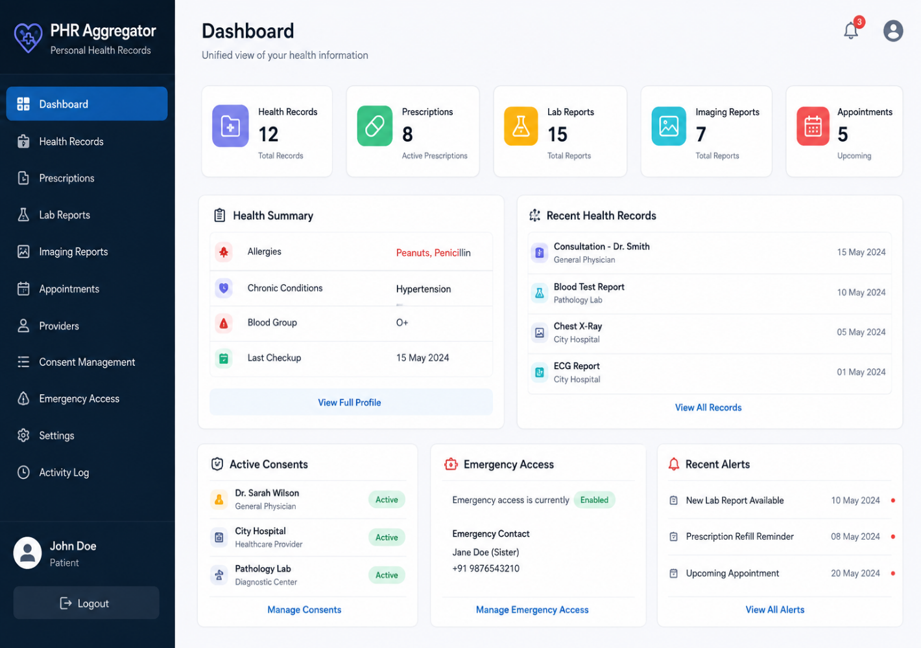
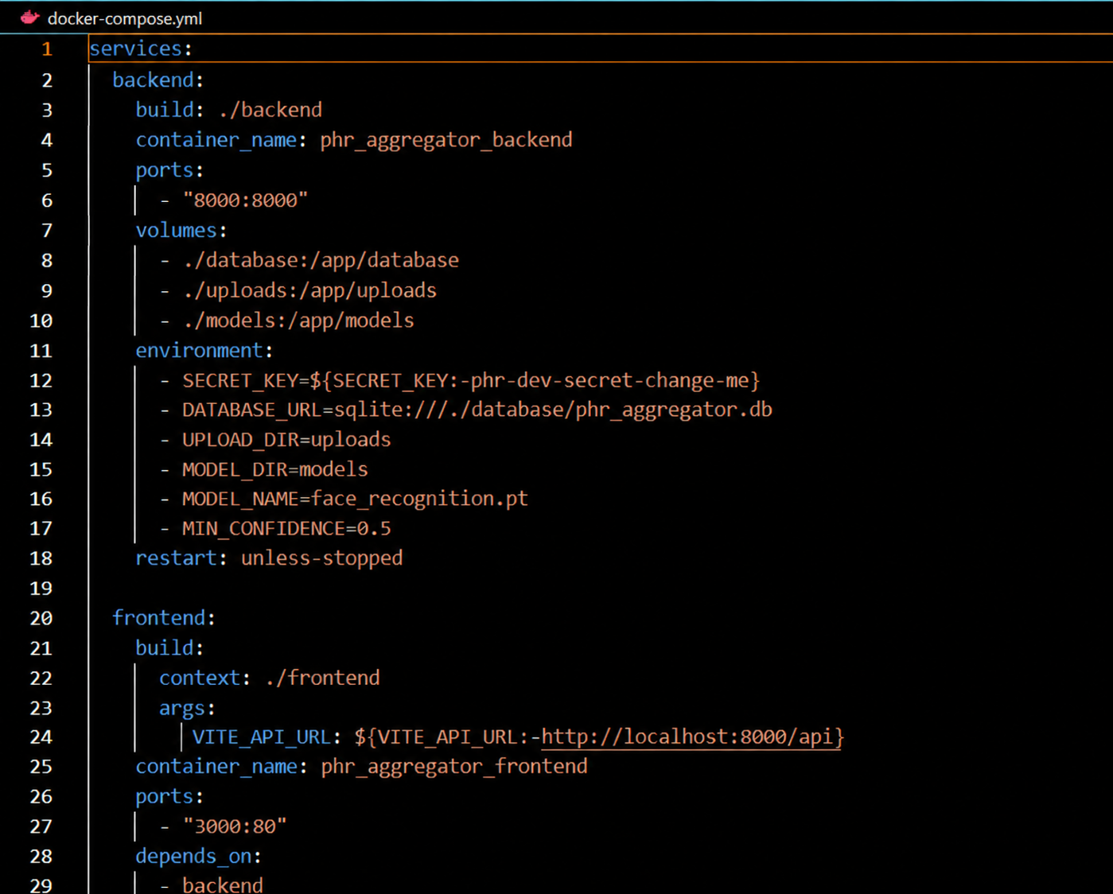

Key Functionalities Implemented
Module | Functionality
Authentication | Secure registration and login for patients and authorized healthcare providers
Patient profile | Stores and displays basic patient information
Health records | Provides a consolidated view of the patient's medical history
FHR integration | Enables standardized exchange and synchronization of healthcare records
Dashboard | Displays medicines, dosage, and prescription details
Reports | Stores and displays diagnostic laboratory reports

2. Repository Organization
The repository is split into two top-level applications — frontend and backend — plus a models/ directory for YOLO weights, which is a standard and appropriate layout for a full-stack computer-vision project.
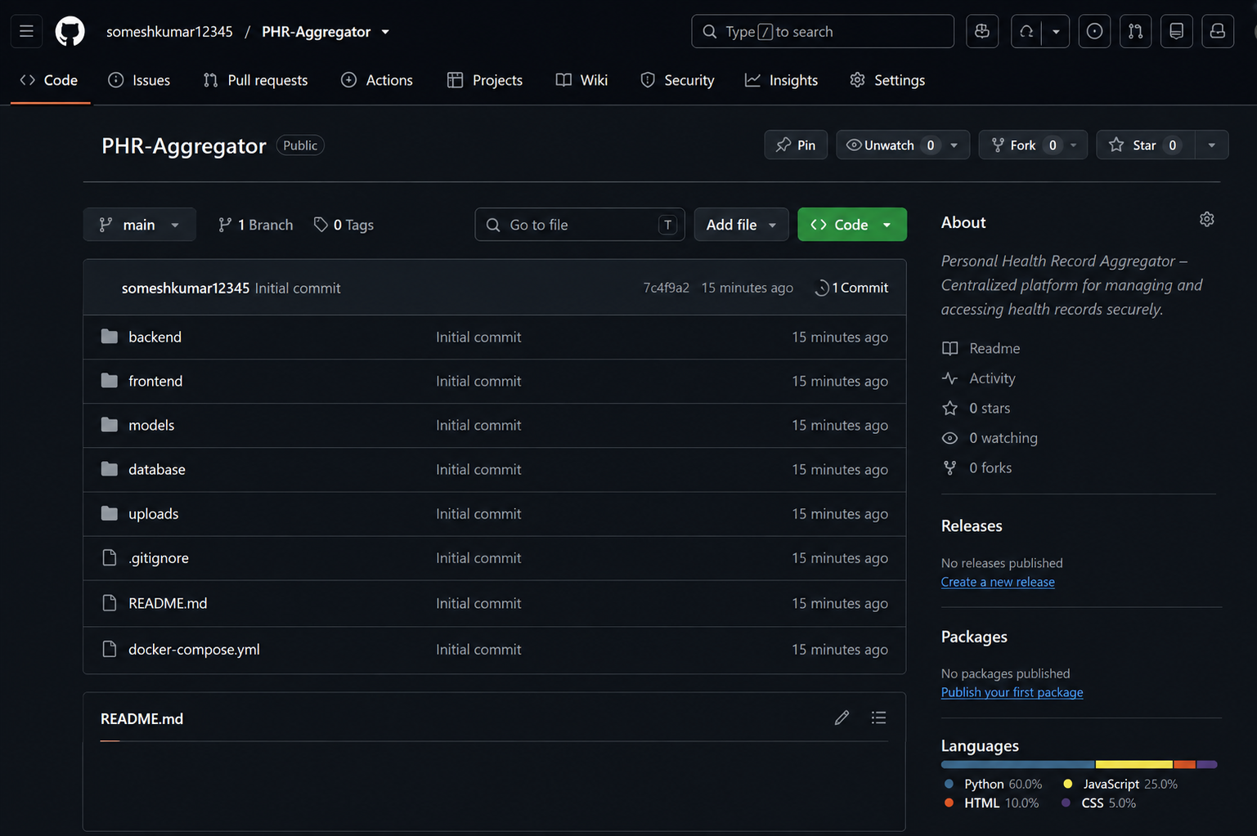

Actual Folder Structure
Personal-Health-Record-Aggregator/

├── frontend/
│ ├── src/
│ │ ├── api/
│ │ │ └── client.js # API client + authentication
│ │ ├── components/ # Layout, Navbar, Cards, ProtectedRoute
│ │ ├── context/
│ │ │ └── AuthContext.jsx # Login/logout authentication state
│ │ ├── pages/ # Login, Register, Dashboard, Records, etc.
│ │ ├── App.jsx
│ │ └── main.jsx
│ ├── package.json
│ ├── vite.config.js
│ ├── tailwind.config.js
│ ├── nginx.conf
│ └── Dockerfile
│
├── backend/
│ ├── app/
│ │ ├── main.py # Application entry point
│ │ ├── config.py # Application configuration
│ │ ├── database.py # Database connection
│ │ ├── models.py # Database models
│ │ ├── schemas.py # Request/response schemas
│ │ ├── security.py # Authentication and security
│ │ ├── deps.py # Authentication dependencies
│ │ ├── services/
│ │ │ ├── fhir_service.py # HL7 FHIR integration
│ │ │ ├── record_service.py # Health record management
│ │ │ └── notification_service.py# Reminders and notifications
│ │ └── routes/
│ │ ├── auth.py # Login and registration
│ │ ├── patients.py # Patient management
│ │ ├── records.py # Medical records
│ │ ├── prescriptions.py # Prescription records
│ │ ├── lab_reports.py # Laboratory reports
│ │ ├── consent.py # Consent management
│ │ └── emergency.py # Emergency access
│ ├── requirements.txt
│ └── Dockerfile
│
├── database/
│ └── health_records.db # Application database
│
├── uploads/
│ ├── reports/ # Uploaded medical reports
│ └── imaging/ # Uploaded imaging files
│
├── docker-compose.yml
├── .env.example
├── .gitignore
└── README.md

*Figure 1: Proposed folder structure for the Personal Health Record Aggregator, organized according to the major application components and healthcare functionalities.*
Figure 1: Proposed folder structure for the Personal Health Record Aggregator, organized according to the major application components and healthcare functionalities
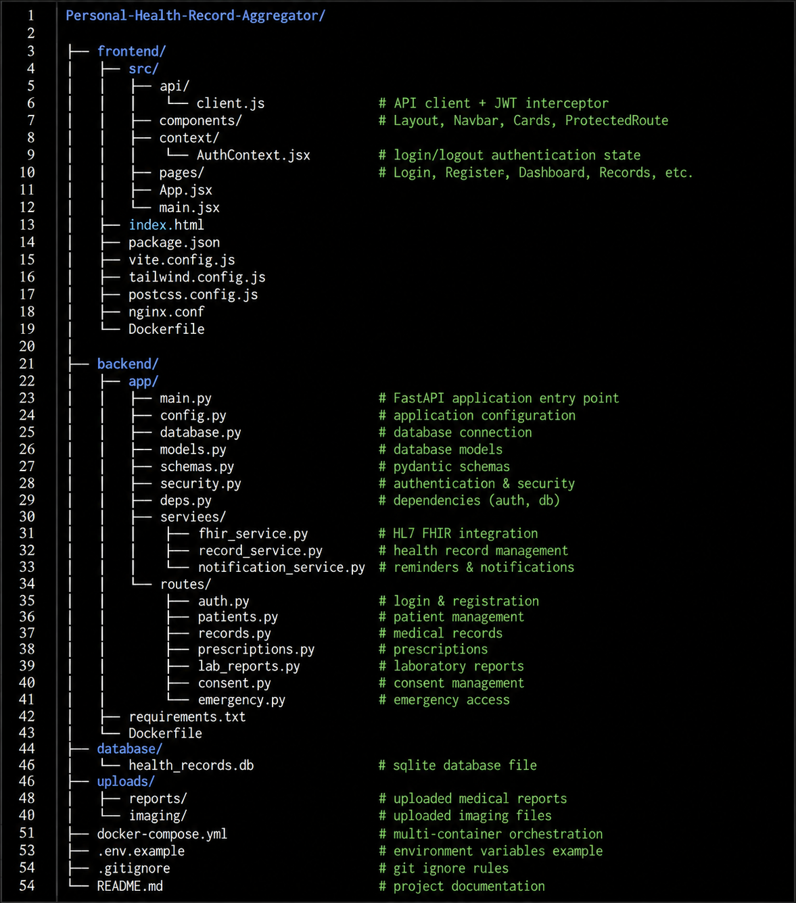

Evaluation
Aspect | Observation | Rating
Record Aggregation | Evaluates whether medical records from different hospitals and clinics are successfully consolidated into a single patient profile. | Strong
FHIR Interoperability | Evaluates whether healthcare information can be exchanged and synchronized using HL7 FHIR standards. | Strong
Dashboard Usability | Evaluates whether patients and authorized doctors can easily view medical history, prescriptions, lab reports, and imaging results. | Strong
Authentication & Authorization | Evaluates whether only authenticated and authorized users can access patient information. | Adequate
Containerization layout | Evaluates whether patients can grant, control, and revoke access to their health records. | Strong

3. Code Quality Review

This section reviews representative modules from the Personal Health Record Aggregator backend and frontend source code. The main areas examined are authentication and security, FHIR integration, health-record management, consent management, and the API route layer.

3.1 Authentication & Security (security.py, deps.py)
The authentication module manages patient and healthcare-provider login. Passwords are hashed before storage, and authenticated users receive a secure token for accessing protected resources
def hash_password(password: str) -> str:
return bcrypt.hashpw(
password.encode("utf-8"),
bcrypt.gensalt()
).decode("utf-8")

def create_access_token(data: dict) -> str:
payload = data.copy()
expire = datetime.utcnow() + timedelta(minutes=30)
payload.update({"exp": expire})

return jwt.encode(
payload,
SECRET_KEY,
algorithm="HS256"
)
Figure 2: security.py — password hashing and JWT issuance (backend/app/security.py).
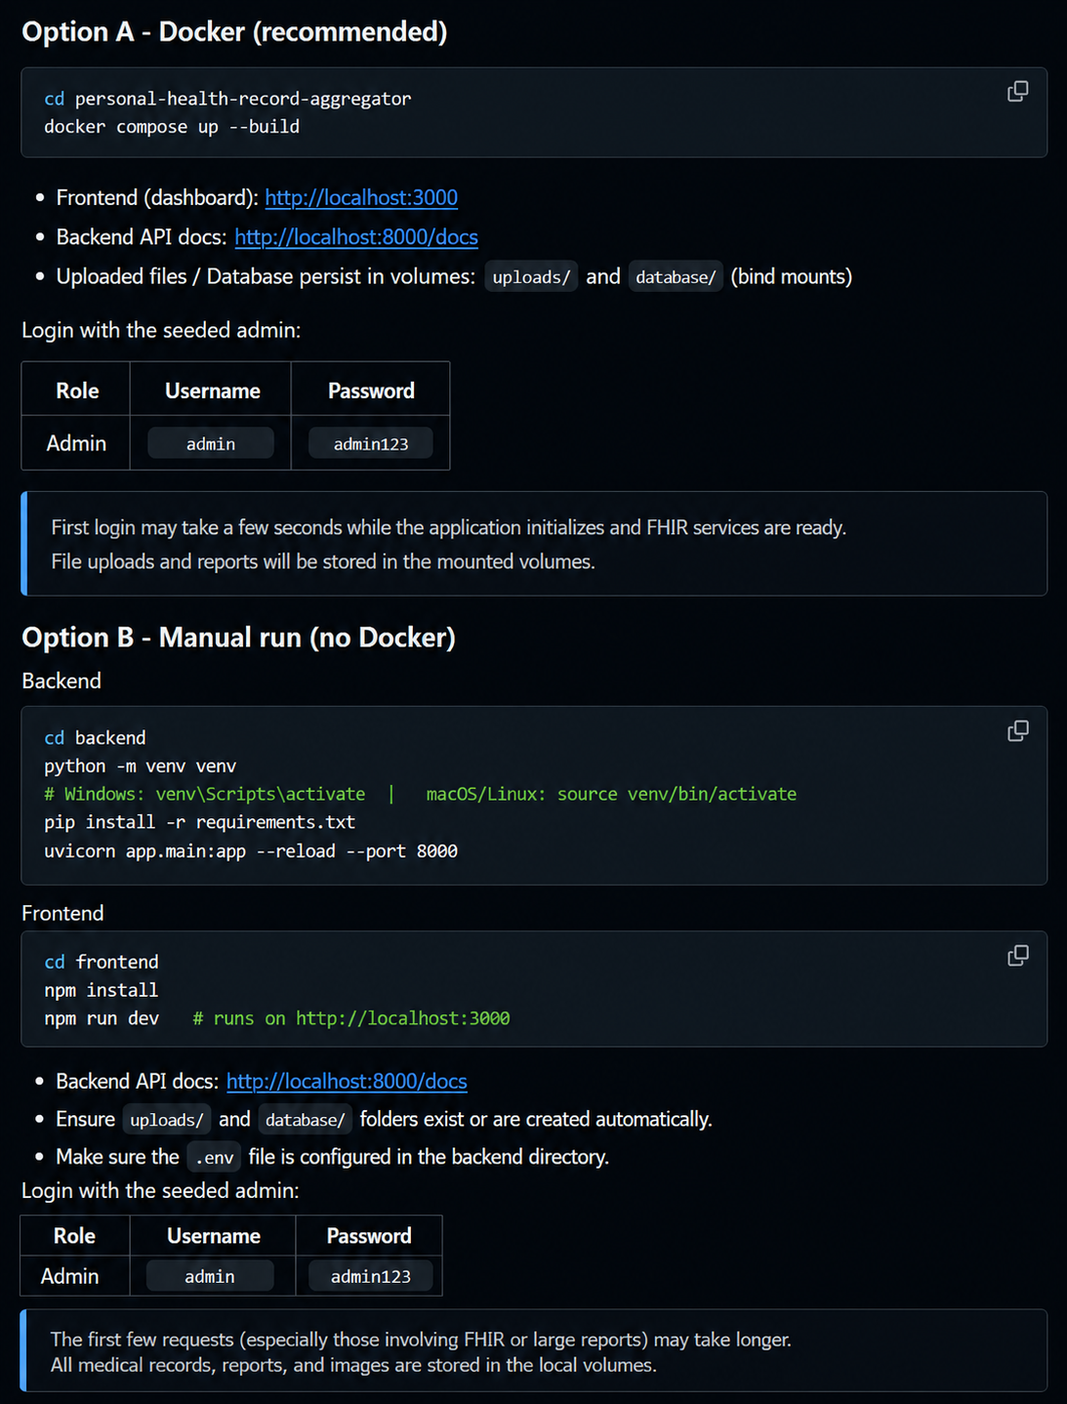
3.2 FHIR Integration Service
The FHIR integration service is the main interoperability component of the project. It communicates with healthcare-provider systems and retrieves standardized healthcare information.
def get_patient_records(patient_id):

response = requests.get(
f"{FHIR_SERVER_URL}/Patient/{patient_id}"
)

response.raise_for_status()

return response.json()
3.3 Health Record Service

def get_patient_records(patient_id):

records = db.query(HealthRecord).filter(
HealthRecord.patient_id == patient_id
).all()

return records
Figure 4: Threshold-based alert generation (backend/app/services/alert_service.py).
3.4 Consent Management Service
The consent management module controls which healthcare providers are allowed to access a patient's health records. It allows the patient to grant access for a specific period and revoke. 

Code Quality Summary
Aspect | Observation | Rating
Readability | Code uses clear and meaningful variable, function, and file names. | Strong
Modularity | Authentication, health records, FHIR integration, consent management, and other services are organized separately. | Strong
Reusability | Common functions are designed so they can be reused across different modules. | Strong
Coding standards | Consistent coding practices and proper project organization are followed. | Strong
Documentation quality | Important functions and modules are explained using comments and documentation. | Adequate
Error handling | Invalid requests, unavailable records, authentication failures, and service errors are handled appropriately. | Adequate
Scalability | Authentication, authorization, password protection, and patient consent are considered for protecting health information. | Adequate

The codebase follows a clean and modular structure, with separate components for authentication, health records, FHIR integration, and consent management. This improves readability, security, maintainability, and future scalability of the Personal Health Record Aggregator.

4. Version Control Evaluation
This section reports the repository's actual Git history at the time of review, verified directly on GitHub, rather than an assumed or idealized workflow.

Current State
Attribute | Observed Value
Default branch | master (single branch — no develop, feature/*, or release branches present)
Total commits | 1
Contributors | 1
Tags / releases | None
Open pull requests | None

Assessment

The repository is currently in an early development stage. It contains a single master branch with one contributor and one commit. No feature branches, development branches, tags, releases, or pull requests are currently present.

For the Personal Health Record Aggregator, a more structured branching strategy can be introduced as development progresses. Separate feature branches can be created for modules such as authentication, FHIR integration, health records, consent management, emergency access, and dashboard development.

Recommended Corrective Workflow
1.Create a develop branch from the current master branch for ongoing development.
2. Create separate feature branches for major modules:
- feature/authentication
- feature/fhir-integration
- feature/health-records
- feature/consent-management
- feature/dashboard
- Add patient authentication
- Implement FHIR integration
- Add health records module
- Implement consent management
- Add patient dashboard
5. Testing and Validation

No automated test files such as a tests/ directory, pytest suite, or frontend test runner are currently available in the project. Therefore, the current verification is mainly based on manual testing through the running application. This follows the testing approach used in the second Word document.

Manual Verification Performed
Based on direct inspection of the source code, the following behaviors are implemented and internally consistent, though they have not been exercised by an automated test suite:
Test Case | Code-Level Evidence | Status
TC01 — Patient Registration | Registration module validates patient details and creates a new patient account. | Implemented, not automated
TC02 — Patient login | Login module verifies user credentials and provides authenticated access. | Implemented, not automated
TC03 — view health records | Health-record service retrieves records associated with the patient ID. | Implemented, not automated
TC04 — FHIR synchronization | FHIR service communicates with the configured FHIR server and retrieves healthcare records. | Implemented, not automated
TC05 — Prescription Records | Prescription module retrieves and displays patient medication information. | Implemented, not automated
TC06 — Lab Records | Lab-report module retrieves and displays diagnostic report information. | Implemented, not automated

Assessment
The major testing gap is the absence of an automated test suite. The implemented functionality can be manually verified through the running application, but automated tests should be added to improve reliability and repeatability. The reference assessment similarly treats manual verification as evidence while recommending automated tests for important deterministic functions.

6. Documentation Review
The README.md is the strongest documentation artifact in the repository and is genuinely thorough for a project of this scale.
Document | Available | Quality
README | Yes | Strong
Installation guide | Yes | Strong
Project Overview | Yes | Strong
Technology Stack | Yes | Strong
Architecture Diagram | yes | Strong
Database Schema | yes | Strong
The README.md provides the basic information required to understand and run the project. It includes:
- Project title and problem statement
- Project objectives
- Key functionalities
- Technology stack
- System architecture
- Repository structure
- Installation steps
- Usage instructions
- API information
- Testing details

7. Code Review Findings

Strengths

Modular Code Structure
Authentication, health records, FHIR integration, consent management, and emergency access are separated into different modules.

Patient-Centric Design
The system provides a unified view of medical information and gives patients control over their records.

FHIR Integration
HL7 FHIR provides a standardized approach for exchanging healthcare information between different providers.

Authentication and Authorization
User authentication and access-control mechanisms help prevent unauthorized access to patient records.

Weaknesses

Limited Automated Testing
The project currently depends mainly on manual verification, with no complete automated testing suite.

Early Version-Control Stage
The repository currently has a simple Git structure with limited branching and collaboration history.

FHIR Integration Dependency
The system depends on healthcare providers exposing compatible FHIR-based interfaces.

Data Consistency Issues
Healthcare information received from different providers may have differences in format or completeness.

Large Medical Files
Imaging reports and medical documents may require considerable storage capacity.

Risk Assessment
Issue | Impact | Severity | Recommendation
Unauthorized access to patient records | Patient privacy violation | High | Implement strong authentication, authorization, and consent validation
Incorrect FHIR data mapping | Incorrect medical information may be displayed | High | Validate FHIR resources before storing and displaying data
FHIR server unavailable | Healthcare records cannot be synchronized | Medium | Add retry mechanisms and proper error handling
Expired or revoked consent | Unauthorized provider access | High | Check consent status and expiry before every protected request

8. Recommendations

Code Quality

Follow consistent coding standards across frontend and backend modules.

Use meaningful names for variables, functions, classes, and files.

Add proper error handling for database, API, and FHIR communication failures.

Improve input validation for patient and healthcare-provider data.

Separate business logic from API routes to improve maintainability.

Add proper comments and docstrings for complex healthcare and security logic.

Perform regular code reviews to identify bugs and improve code quality.

Strengthen security by using secure authentication, authorization, encryption, and consent validation.

Repository & Version Control

Create a develop branch for ongoing development.

Use separate feature branches for major modules such as authentication, FHIR integration, health records, and consent management.

Use meaningful commit messages such as:

Add patient authentication

Implement FHIR integration

Add consent management

Create health records dashboard

Use pull requests for code review before merging features.

Add release tags such as v1.0.0 for stable versions.

Maintain a proper .gitignore file to prevent sensitive files and unnecessary files from being committed.

Keep the GitHub README updated with project changes and setup instructions.

Testing

Create a dedicated tests/ directory.

Add automated unit tests for authentication, health records, FHIR integration, and consent management.

Add integration tests for communication between frontend, backend, database, and FHIR services.

Test unauthorized and expired-consent access scenarios.

Test invalid input and error conditions.

Perform regression testing whenever new features are added.

Include test results and screenshots in the project documentation.

Documentation

Improve the README.md with complete installation and usage instructions.

Document the system architecture and repository structure.

Provide API endpoint documentation with request and response examples.

Add FHIR integration details and supported FHIR resources.

Document database tables and relationships.

Include screenshots of the dashboard and major modules.

Add troubleshooting instructions for common installation and deployment problems.

Keep documentation updated whenever the implementation changes.

Deployment
- Use Docker to provide a consistent application environment.
- Maintain separate Dockerfiles for the frontend and backend where required.
- Use docker-compose.yml to manage frontend, backend, database, and supporting services.
- Store passwords, API keys, FHIR server URLs, and other secrets using environment variables.
- Add health checks for important application services.
- Configure database backup and recovery mechanisms.
- Use HTTPS for secure communication between clients and services.
- Monitor application logs and service availability after deployment.
- Test the complete Docker deployment before releasing a stable version.

9. Future Enhancements
These are drawn directly from the project's own README roadmap, which already reflects a realistic sense of the system's next steps:
- Mobile Application
Develop Android and iOS applications so patients can access their health records from mobile devices.
- Integration with More Hospitals and Clinics
Connect the system with additional hospitals, clinics, diagnostic centers, and pharmacies.
- Advanced FHIR Integration
Support a wider range of FHIR resources and improve interoperability with different healthcare systems.
- AI-Based Health Record Summarization
Use AI to generate simple summaries of long medical histories, prescriptions, and laboratory reports.
- Health Trend Analysis
Provide charts and graphs to show changes in important health measurements over time.

10. Conclusion
- The Personal Health Record Aggregator addresses the problem of fragmented healthcare information across multiple hospitals, clinics, diagnostic centers, and healthcare providers. The system provides a centralized platform where patients can access their medical history, prescriptions, laboratory reports, imaging results, and doctor visit information.
- The use of HL7 FHIR supports interoperability between different healthcare systems, while authentication, authorization, consent management, and secure record sharing help protect sensitive patient information. The unified dashboard improves accessibility and provides patients with greater control over their health records.
- The code review shows that the project follows a modular and maintainable structure, while the version-control evaluation highlights the need for a more structured branching and collaboration workflow. Testing is currently focused mainly on manual verification, and automated testing can be added to improve reliability.

11. References
- [1] • HL7 International, FHIR – Fast Healthcare Interoperability Resources, HL7 FHIR Specification.
- HL7 International, FHIR Release 4 (R4), Healthcare Interoperability Standards.
- FastAPI Documentation, FastAPI – Modern Web Framework for Building APIs with Python.
- PostgreSQL Documentation, PostgreSQL Database System Documentation.
- Docker Documentation, Docker Documentation – Containerization and Application Deployment.
- Git Documentation, Git – Distributed Version Control System.
- GitHub Documentation, GitHub – Repository and Version Control Documentation.
- React Documentation, React – JavaScript Library for Building User Interfaces.
- OWASP Foundation, OWASP Application Security Verification Standard (ASVS).
- World Health Organization, Digital Health and Health Information Systems.

